Kaitaia Publishing Collective CSC 3710 Systems Analysis & Design

Kaitaia Publishing Collective

Haris Khan, Konan Kouame, Ryan Horwitz, Christopher Luzzi, Benjamin Jackson CSC 3710 Systems Analysis & Design

Fitchburg State University

Use Case 1 - Konan Kouame

Use Case 2- Benjamin Jackson

Use Case 3 - Christopher Luzzi

Use case 4 - Haris Khan

Use Case 5 - Ryan Horwitz

DFD - Group work

Kaitaia Publishing Collective CSC 3710 Systems Analysis & Design

Use Case 1: Konan Kouame

| **Use Case Name:** Make/edit contract**ID**: 1 **Priority**: High |
| --- |
| **Primary Actor:** Author |
| **Short Description**: This process will allow new or existing authors to make or accept new contracts for the publishing company. |
| **Trigger:** Send a request to the administrator for approval  **Type:** External |
| **Major Inputs**  **Major Outputs**  Descriptions: Source:  Description: Destination:  Author Name Author  Author info Author Account  Author ID Author  Administrator Administrator ID |
| **Major Steps Performed**  **Information for Steps**  Make/Edit contract  Author name  Access denied/ email the administrator  Date of birth  Address  Authorization granted by the administrator,  allowed to make or edit contract  Phone number  Administrator  Author status |

Kaitaia Publishing Collective CSC 3710 Systems Analysis & Design

Use Case 2: Benjamin

| **Use Case Name:** Submitting Manuscript **ID:**  **Priority:** High  UC-2 |
| --- |

**Actor:** Collective Employee

**Description:** Employee logs the author’s submission & details into database for record keeping **Trigger:** Author submits their work to Kaitaia Publishing Collective

**Type:**

**Preconditions:**

1. Author submits work and contact information.

2. Collective employee accesses database registry.

3. Database is online.

**Normal Course:**

1. Employee starts a registry form

2. System provides form to enter author information

3. Employee submits author contact information

4. System assigns author an ID

5. System saves contact information for future reference

6. System provides form for author manuscript submission

A. Employee selects “Digital manuscript submission” option

● Employee uploads submission file to registry form

B Employee selects “Physical manuscript submission” option

7. Employee fills out form

8. System assigns the manuscript submission an ID

9. System saves manuscript submission details for future reference

10. Author is emailed with proof of their manuscript being entered into Collective’s database **Postconditions:**

1. Author’s manuscript submission is saved to database

2. Author is emailed with proof of their work being entered into Collective’s database

| **Summary Inputs Source** |
| --- |
| Author contact information  Employee  Author manuscript submission  Employee |

Kaitaia Publishing Collective CSC 3710 Systems Analysis & Design

| Submission ID Employee |
| --- |
| **Summary Outputs Destination** |
| Registry Form  Database  Submission approval  Database  Email  Author |

Kaitaia Publishing Collective CSC 3710 Systems Analysis & Design

Chris Luzzi

| **Use Case Name**: Manuscript Inventory Check**ID**: 3 **Priority**: High |
| --- |
| **Primary Actor:** Author |
| **Short Description**: This is to get how much stock we have of a specific manuscript from an author after we have proofread it and published it. |
| Trigger: Proofread and publishment completed  Type: External |
| **Major Inputs**  **Major Outputs**  Descriptions: Source:  Description: Destination:  Author Name Author  Manuscript Stock Manuscript file  Manuscript Title Manuscript file  Manuscript Title Author  **Major Steps Performed**  **Information for Steps**  Search authors name  Authors name  Search title title of manuscript  Manuscript information  Number in stock  Check current stock for authors |

Kaitaia Publishing Collective CSC 3710 Systems Analysis & Design

Haris Khan

| **Use Case Name:** Deletion of  submissions **ID:** 4 **Priority:** Low to moderate |
| --- |
| **Primary Actor**: Author |
| **Short Description:** This will allow users to delete submissions they may have accidentally created or no longer need. |
| **Trigger**: Author submits work, needs administrators approval to remove submission. **Type**: External |
| **Major Inputs**  **Major Outputs**  Description Source  Description: Destination  Author ID Author  Author Info Author Account  Administrator ID Administrator  Confirmation of contract deletion Submitted contract |
| Major Steps Performed:  Information for Steps:  1. Author name search  1. Author information required  2. Search for submitted contract  2. Contract details needed.  ID  3. Administrator needs to accept removal request  3. Request removal of contract  from author after |

Kaitaia Publishing Collective CSC 3710 Systems Analysis & Design

Ryan Horwitz

| **Use Case Name**: Proofreading the manuscript**ID:** 5 **Priority**: High |
| --- |
| **Primary Actor**: Author |
| **Short Description**: This will allow the publishing company to proofread any manuscript before publishing. |
| **Trigger**: Received manuscript for proofreading  **Type**: External |
| Major Inputs:  Major Outputs:  Description: Destination:  Descriptions: Source:  Manuscript body Manuscript file  Manuscript title Author  Manuscript title Manuscript file  Employee ID Database |
| **Major Steps Performed:**  **Information for Steps:**  Receive manuscript  Manuscript added  Fix any errors of manuscript  Proofread manuscript  Employee ID  Employee ID for who proofread  manuscript |

Kaitaia Publishing Collective CSC 3710 Systems Analysis & Design 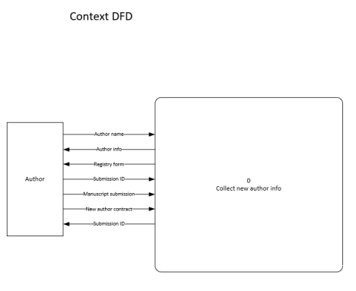

Comment:

1. in your use cases, you have at least two actors: "Author" and

"Collective Employee". However, in your context diagram,

you only have "Author".

Kaitaia Publishing Collective CSC 3710 Systems Analysis & Design Comment: This level 0 DFD doesn't use standard symbols for each of the components. There are many syntax and semantic errors. For example:

DFD

1. There is no data store for submitted manuscripts

2. For process "Make/Edit Contract", it should be "KPC General Manager" who creates and negotiates contracts. It should not be "Author" who sends request to make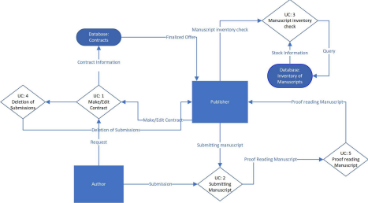/edit contract.

3. There are more syntax and semantic errors

Use Case 2 - Level 1 DFD 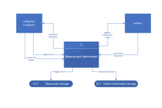

Comment:

1. Each use case (including Use Case 2) should be correspond to a level 0 DFD fragment not to level 1 DFD.

2. Also, each level 1 diagram should be corresponding to a process in level 0. The number for each level 1 process should be like 2.1, 2.2, and 2.3 if it is the level 1 DFD corresponding to process 2 in level 0 DFD.

Kaitaia Publishing Collective CSC 3710 Systems Analysis & Design

Same comments as the ones for Use Case 2.

Use Case 4 - Level 1 DFD

